eCommerce Analytics Training
2026
Vaishnavi Kamthe

Assignment 1B.2

Question
1. Open the dataset and find a table that resembles a sales order (e.g., olist_orders_dataset.csv), load the data in Big Query.
2. Identify the following:
- How many unique customers exist?
- What is the total number of orders?
- What is the average number of products per order?
3. Choose any single customer and trace their:
- Order date(s)
- Number of items ordered
- Total payment made

Tools & Approach
Due to the absence of an active cloud billing setup required for BigQuery, the dataset was analyzed using Microsoft Excel. The same analytical logic that would be applied in SQL-based environments was replicated using structured tables, pivot tables, and cross-referencing across datasets.

1. Loading the data
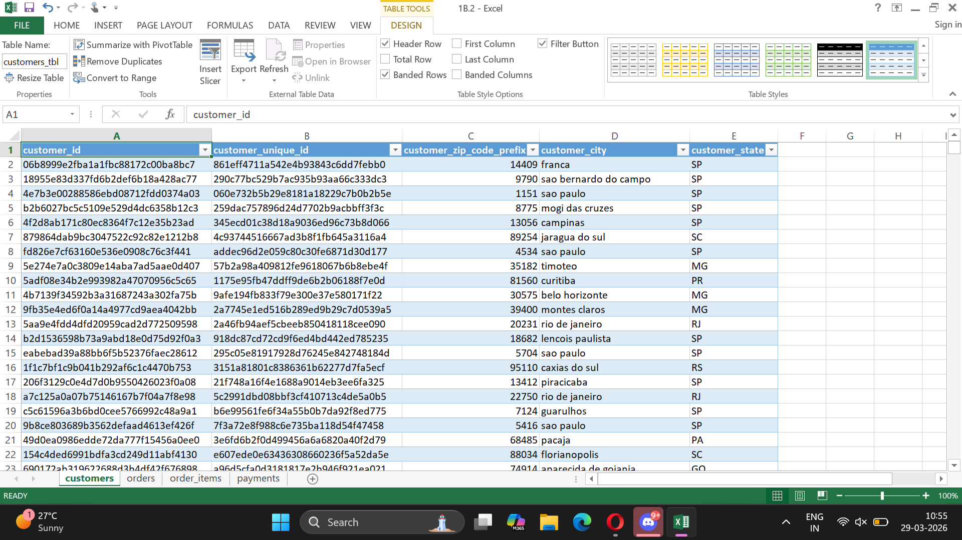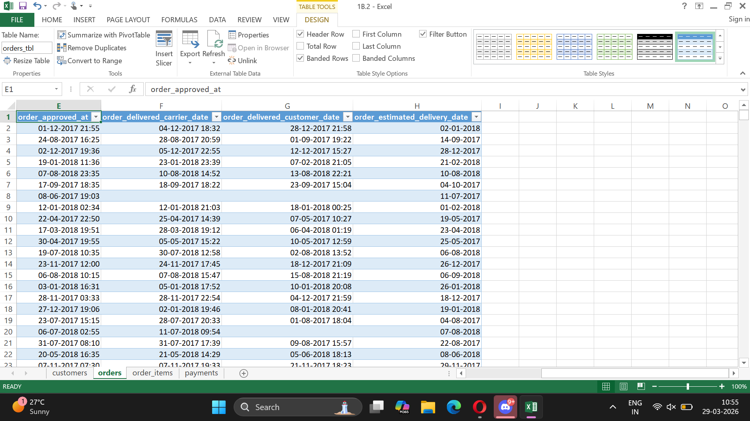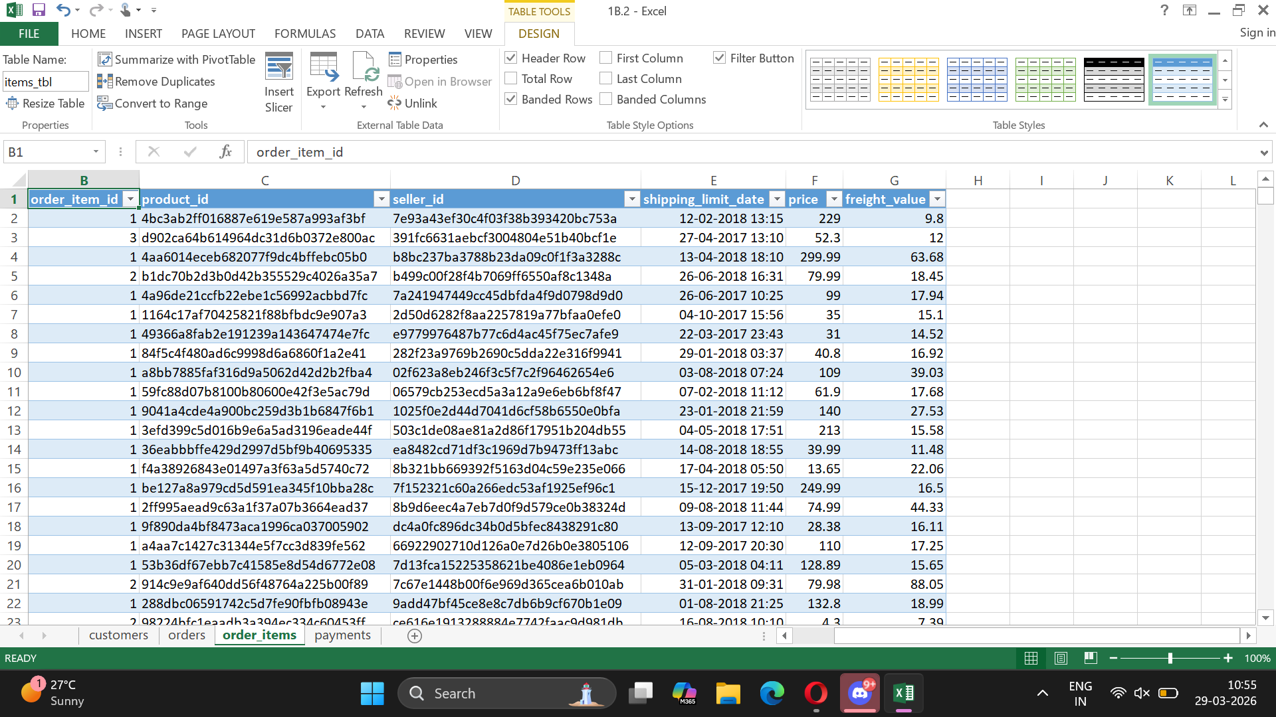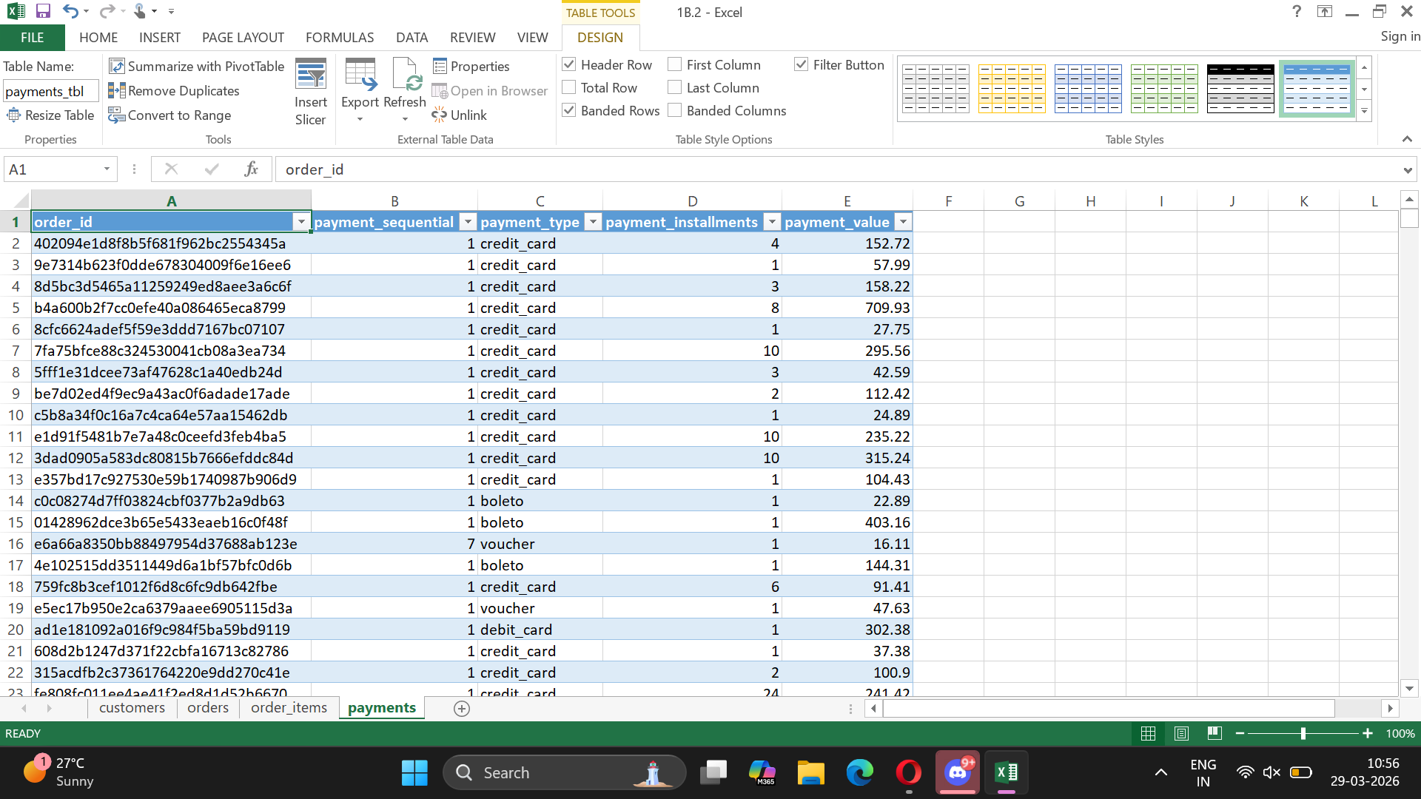

2. Identification
How many unique customers exist?
The dataset contains 96096 unique customers when measured using customer_unique_id, which represents actual individuals.
It is important to note that customer_id is transaction-level and may create multiple entries for the same user, whereas customer_unique_id provides a true customer-level view.
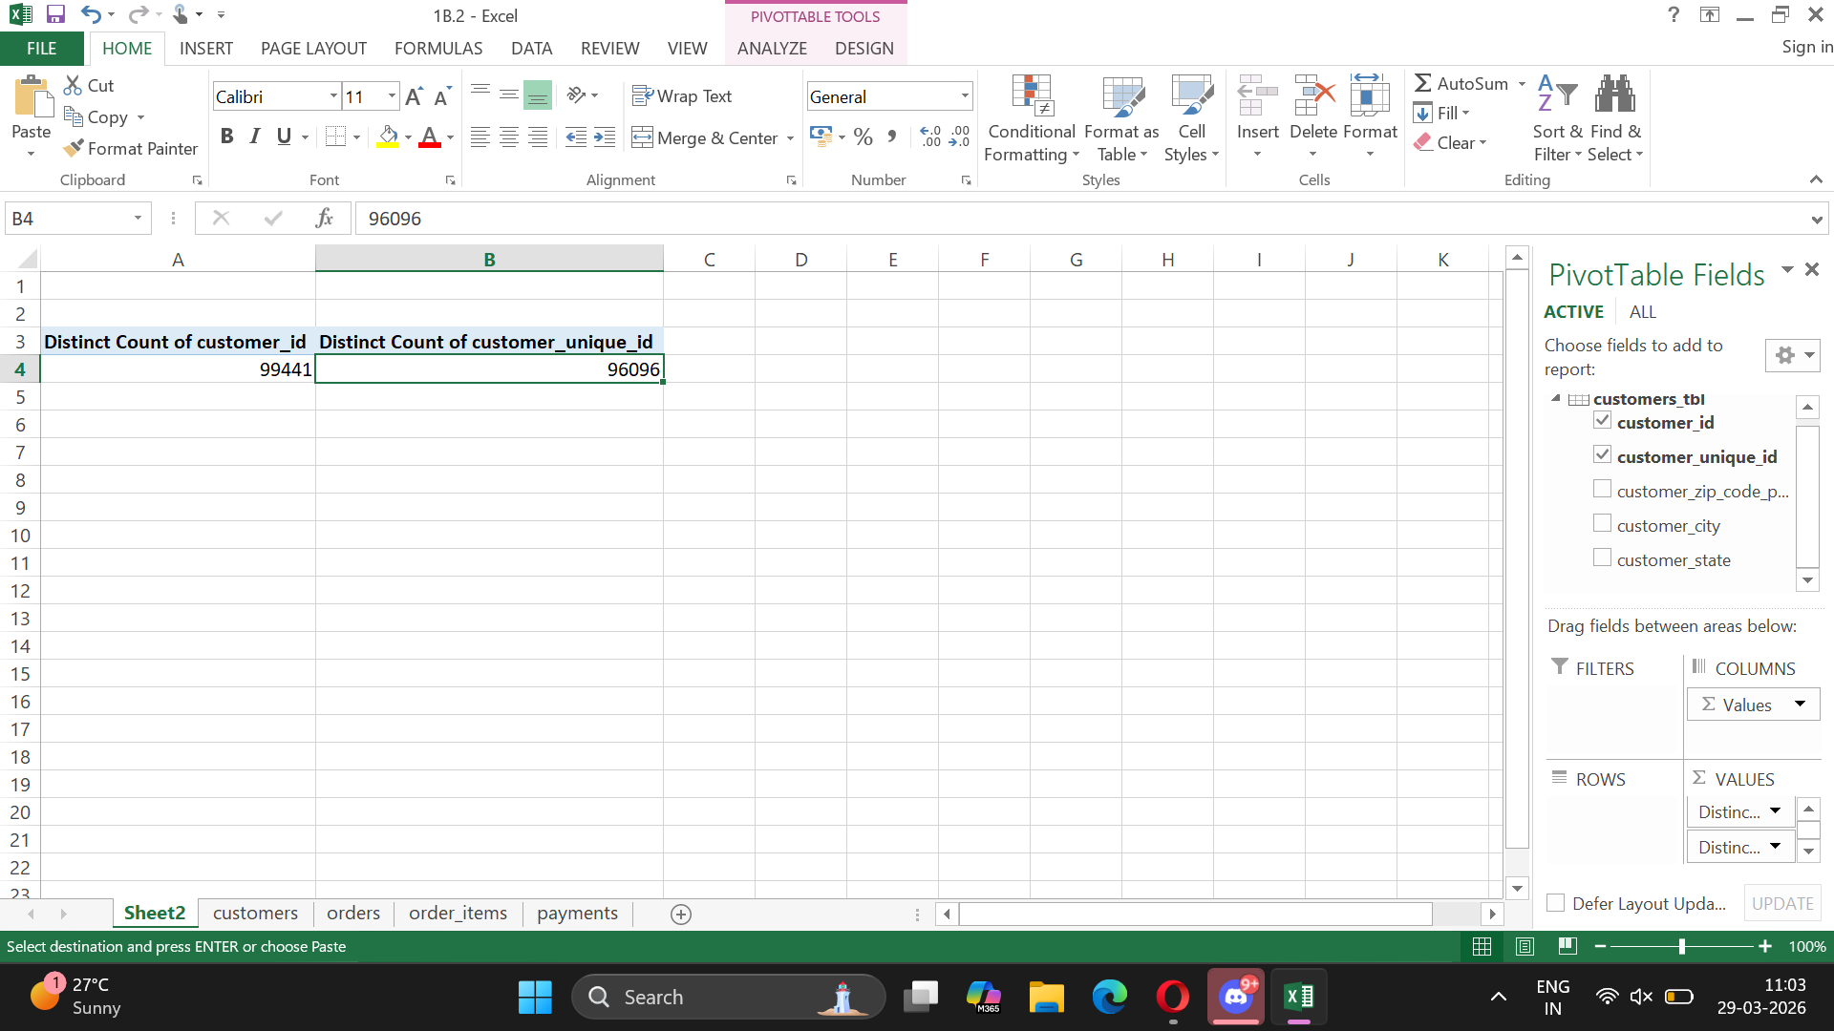

What is the total number of orders?
The dataset contains 99442 total orders, representing the total number of transactions processed in the system.
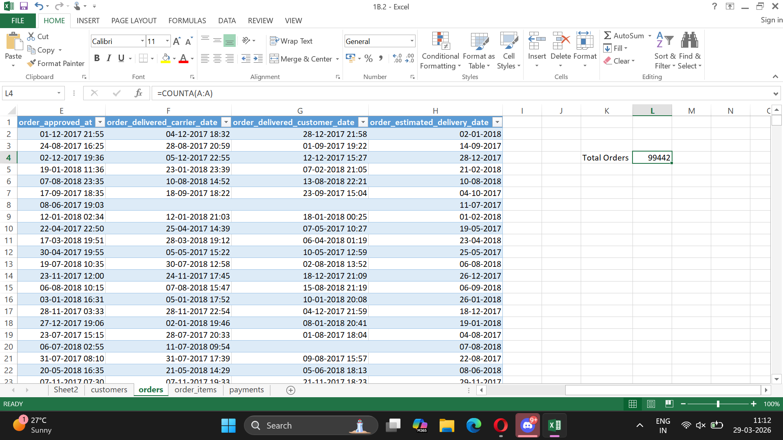
What is the average number of products per order?
On average, each order contains 1.141730687 products, indicating customer basket size and purchasing behavior.
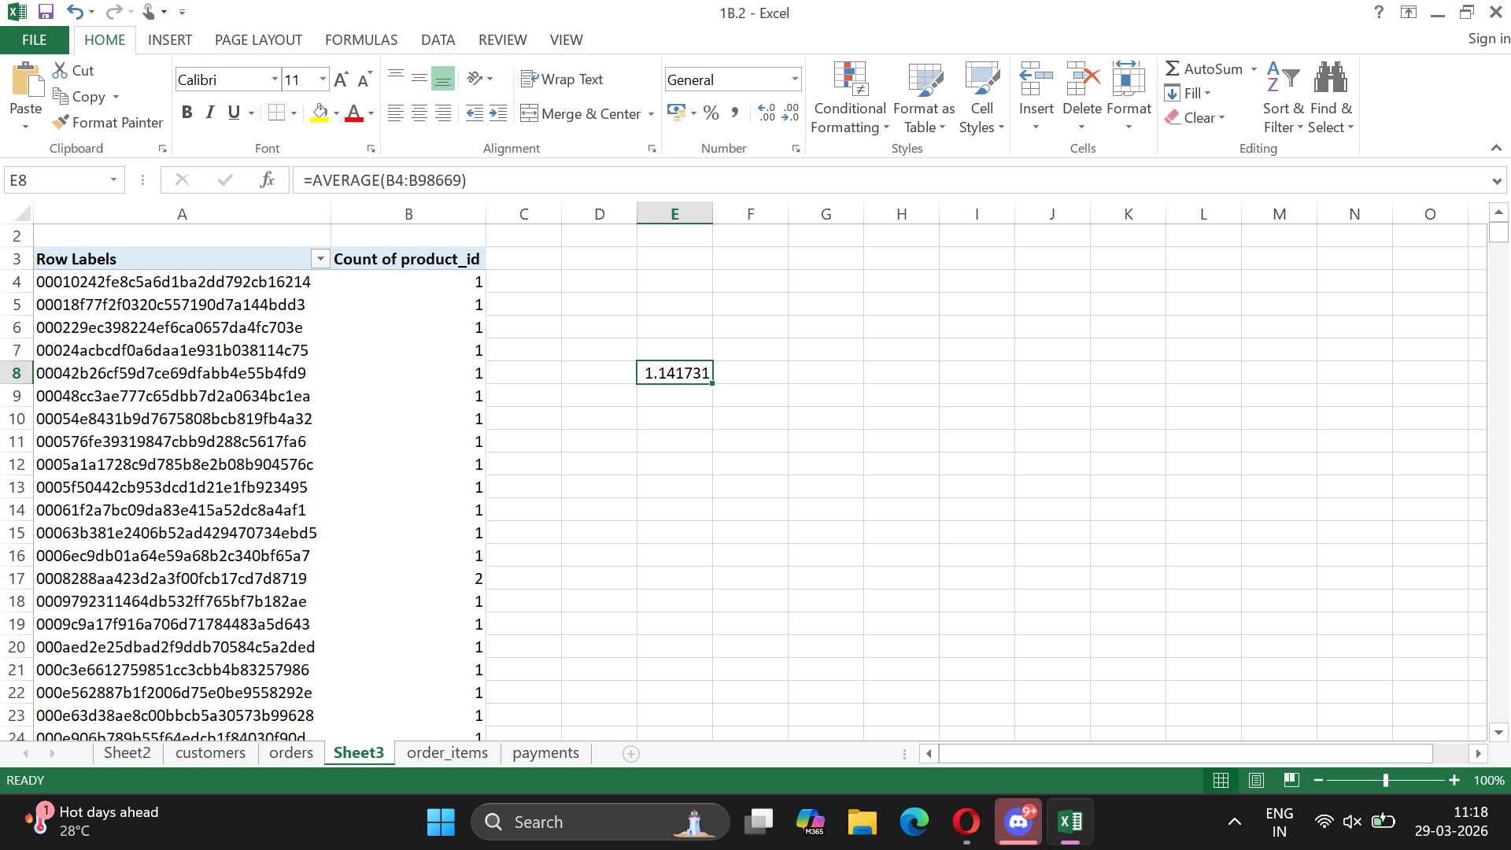

3. Customer Tracing
Chosen customer_unique_id = “00172711b30d52eea8b313a7f2cced02”
All related customer_ids:
Customer Orders:
The selected customer placed orders on the following date(s):
- 13-08-2018 09:14
- 28-07-2018 00:23
Items Purchased:
The customer purchased a total of 1 item across their orders. (2, but one of it was canceled)
Total Payment:
The total payment made by the customer across all orders is 244.14
